**Department wise Performance Analysis**

The analysis assesses the performance of employees across different departments to identify any disparities or trends.

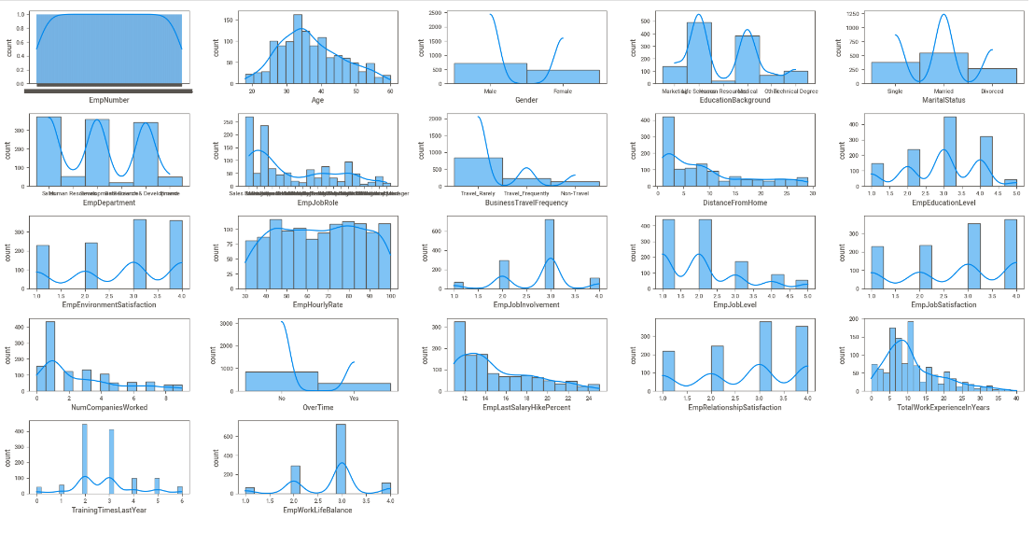

**Department Wise Performance Analysis**

Conduct a thorough analysis to determine the key factors that significantly impact employee performance. These factors could include variables such as job satisfaction, workload, training opportunities, etc.

**Feature Importance Analysis**

Determine the relative importance of different features in predicting employee performance. This analysis will help prioritize interventions and initiatives aimed at improving employee performance.

**Domain Analysis**

1. **EmpNumber**: This column likely contains a unique identifier for each employee.
2. **Age**: The age of the employee.
3. **Gender**: The gender of the employee.
4. **EducationBackground**: The educational background of the employee, such as their highest level of education attained (e.g., high school diploma, bachelor's degree, etc.).
5. **MaritalStatus**: The marital status of the employee (e.g., single, married, divorced, etc.).
6. **EmpDepartment**: The department in which the employee works.
7. **EmpJobRole**: The specific job role or position of the employee within their department.
8. **BusinessTravelFrequency**: How frequently the employee travels for business purposes.
9. **DistanceFromHome**: The distance between the employee's home and their workplace.
10. **EmpEducationLevel**: The education level of the employee, which could be related to their qualifications and skill level.
11. **EmpEnvironmentSatisfaction**: The level of satisfaction the employee feels with their work environment.
12. **EmpHourlyRate**: The employee's hourly rate of pay.
13. **EmpJobInvolvement**: The level of involvement or engagement the employee has in their job role.
14. **EmpJobLevel**: The hierarchical level of the employee's job role within the company. Higher job levels may be associated with greater responsibilities and potentially higher performance expectations.
15. **EmpJobSatisfaction**: The level of job satisfaction reported by the employee.
16. **NumCompaniesWorked**: The number of companies the employee has worked for previously.
17. **OverTime**: Whether the employee works overtime or not.
18. **EmpLastSalaryHikePercent**: The percentage of the employee's last salary hike.
19. **EmpRelationshipSatisfaction**: The level of satisfaction the employee feels with their relationships at work.
20. **TotalWorkExperienceInYears**: The total work experience of the employee in years.
21. **TrainingTimesLastYear**: The number of times the employee received training in the last year.
22. **EmpWorkLifeBalance**: The employee's perceived work-life balance.
23. **ExperienceYearsAtThisCompany**: The number of years the employee has worked at INX Future Inc.
24. **ExperienceYearsInCurrentRole**: The number of years the employee has been in their current job role.
25. **YearsSinceLastPromotion**: The number of years since the employee's last promotion.
26. **YearsWithCurrManager**: The number of years the employee has been working with their current manager.
27. **Attrition**: Whether the employee has left the company or not.
28. **PerformanceRating**: The performance rating assigned to the employee.

**Correlation Analysis**

Correlation Matrix Heatmap. correlation analysis is exploring relationships between different variables and employee performance metrics. This will help uncover potential causal factors influencing performance outcomes

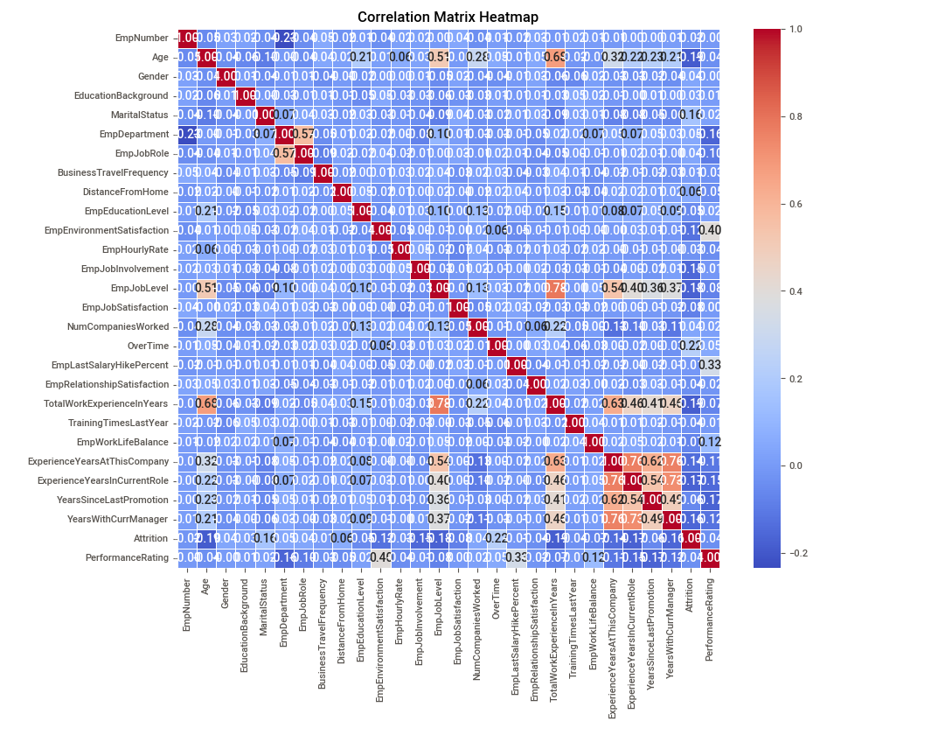

**Visualization of Results**:

Used visualizations such as histograms, scatter plots, and heatmaps to effectively communicate analysis findings. Visual representations of data can make complex patterns and relationships more accessible and understandable.

In this histograms plot comparing the data which is available in specific columns.

**Recommendations for Performance Improvement**:

Based on the analysis findings

1. Conduct regular performance reviews to assess progress and identify areas for improvement.
2. Encourage open communication and address any concerns or challenges proactively.
3. Offer constructive feedback on strengths and areas needing improvement.
4. Collaborate with the employee to develop a personalized action plan for development.
5. Create a supportive and inclusive workplace culture that values teamwork and collaboration.
6. Provide constructive feedback and coaching to support continuous learning and growth.
7. Identify areas for skill development and offer relevant training programs or resources.

**Validation of Analysis Results**:

The results of the analysis using appropriate statistical methods and techniques.

1. Recognize and appreciate the employee's contributions and achievements.
2. Ensure that analysis results are rigorously validated through appropriate methodologies and techniques.
3. Continuously monitor and evaluate analysis outcomes to ensure consistency and validity over time.

**Insights**: We are using sweetviz report to visualize and find insights.

**Univariate Analysis**

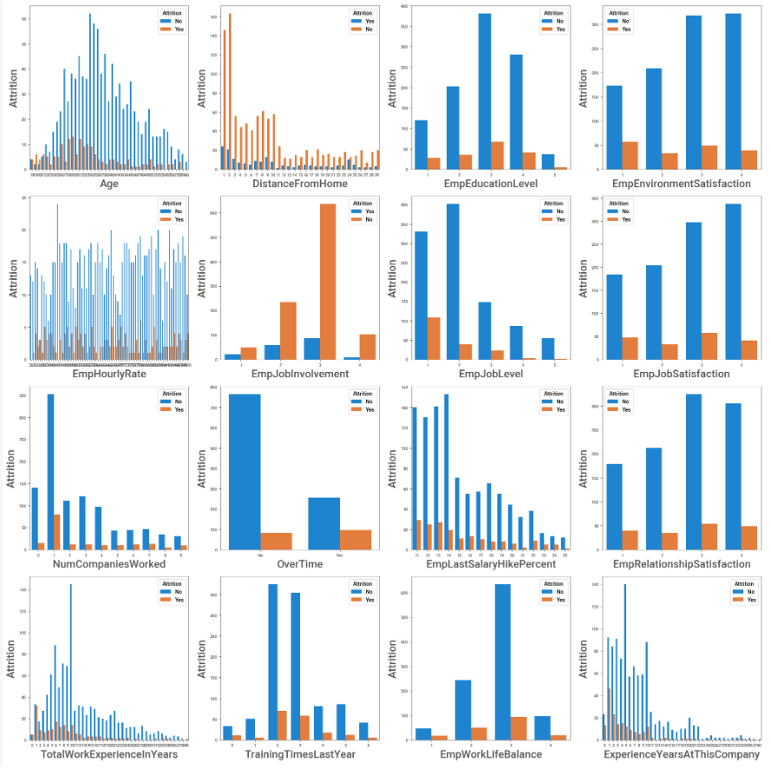

**Insights from univariate analysis**

* Employee between the age group 30-35 is the majority.
* 70% of the people travel rarely, 20% travel frequently rest do not travel.
* Majority of the employees belong to research and development.
* Almost 35% of the people are nearer to the office i.e. the distance from their home is lesser than or equal to 10.
* More than 60% of the people have educational qualification of 2 and 4.
* Majority (40%) of the people are from life science field and 30% are from medical field.
* 60% of the people are almost satisfied with environment condition of the office with more than 3 and 4 ratings.
* Gender count: 60% male 40% female.
* Almost 40% of the people have partial involvement in job and 20% have good involvement.
* More than 45% employees seem to be satisfied with their job.
* 50% of the people are married, 30% single and the rest are divorced.
* 40% of the employee have worked experience less than 10 year
* 15% of the people have worked for less than 1 company which implies they are freshers.
* 30% of the people have worked for more than 5 companies.
* 80% of the people have average work rating.

Bivariate Analysis

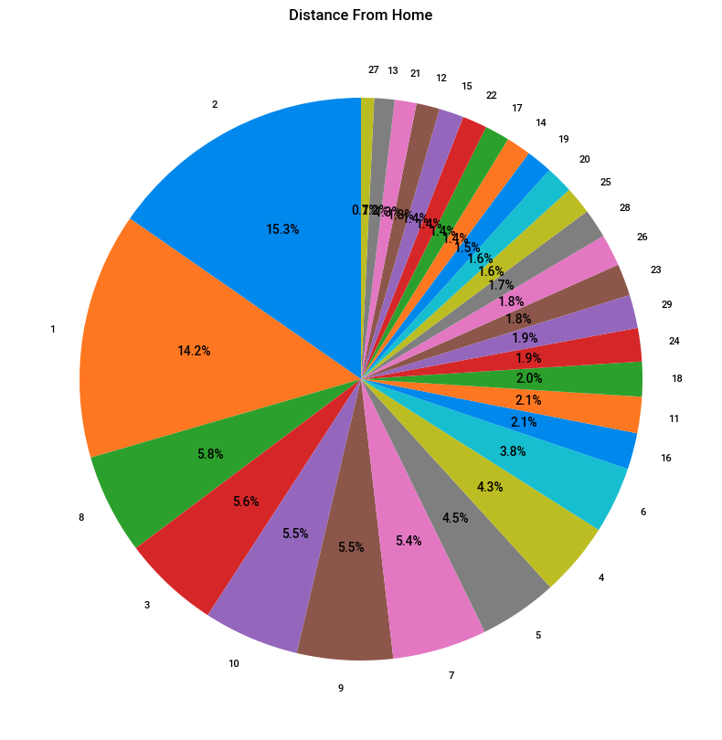

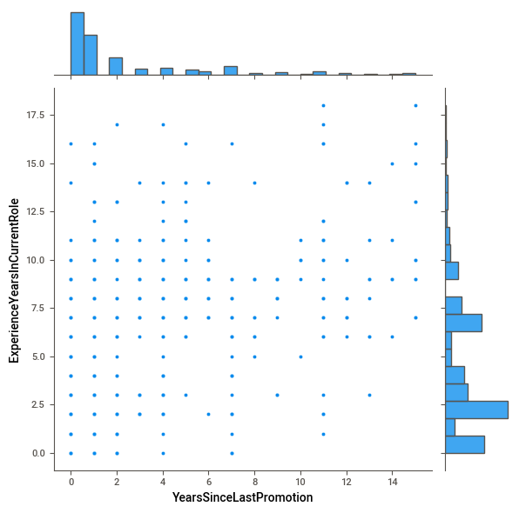

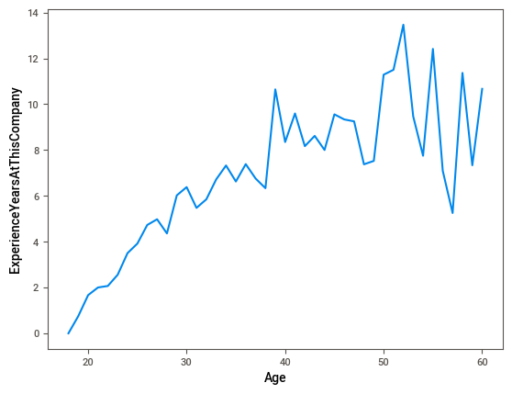

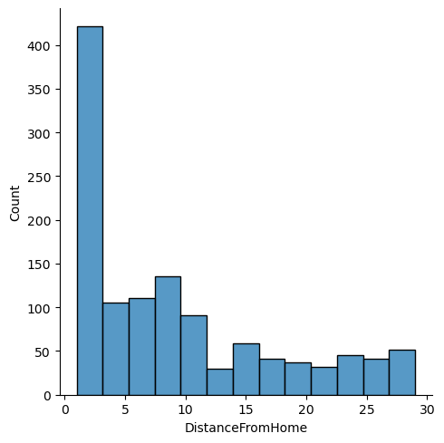

**Insights from bivariant analysis**

* More male employees are expected to quit their job.
* People who travel more are more expected to leave the job.
* People who do not do overtime do not leave the job.
* Singles are expected to quit the job.
* People from Development, Senior developer and sales executive are more probably leaving their job.

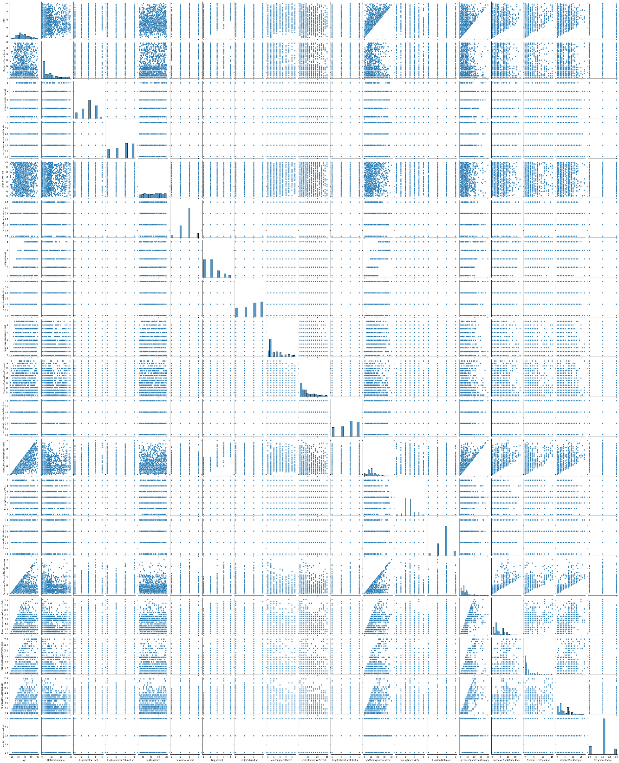

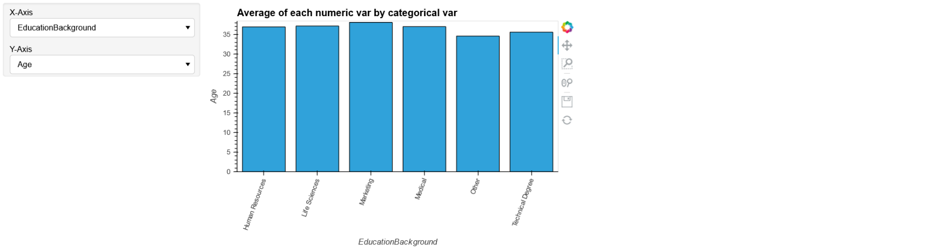

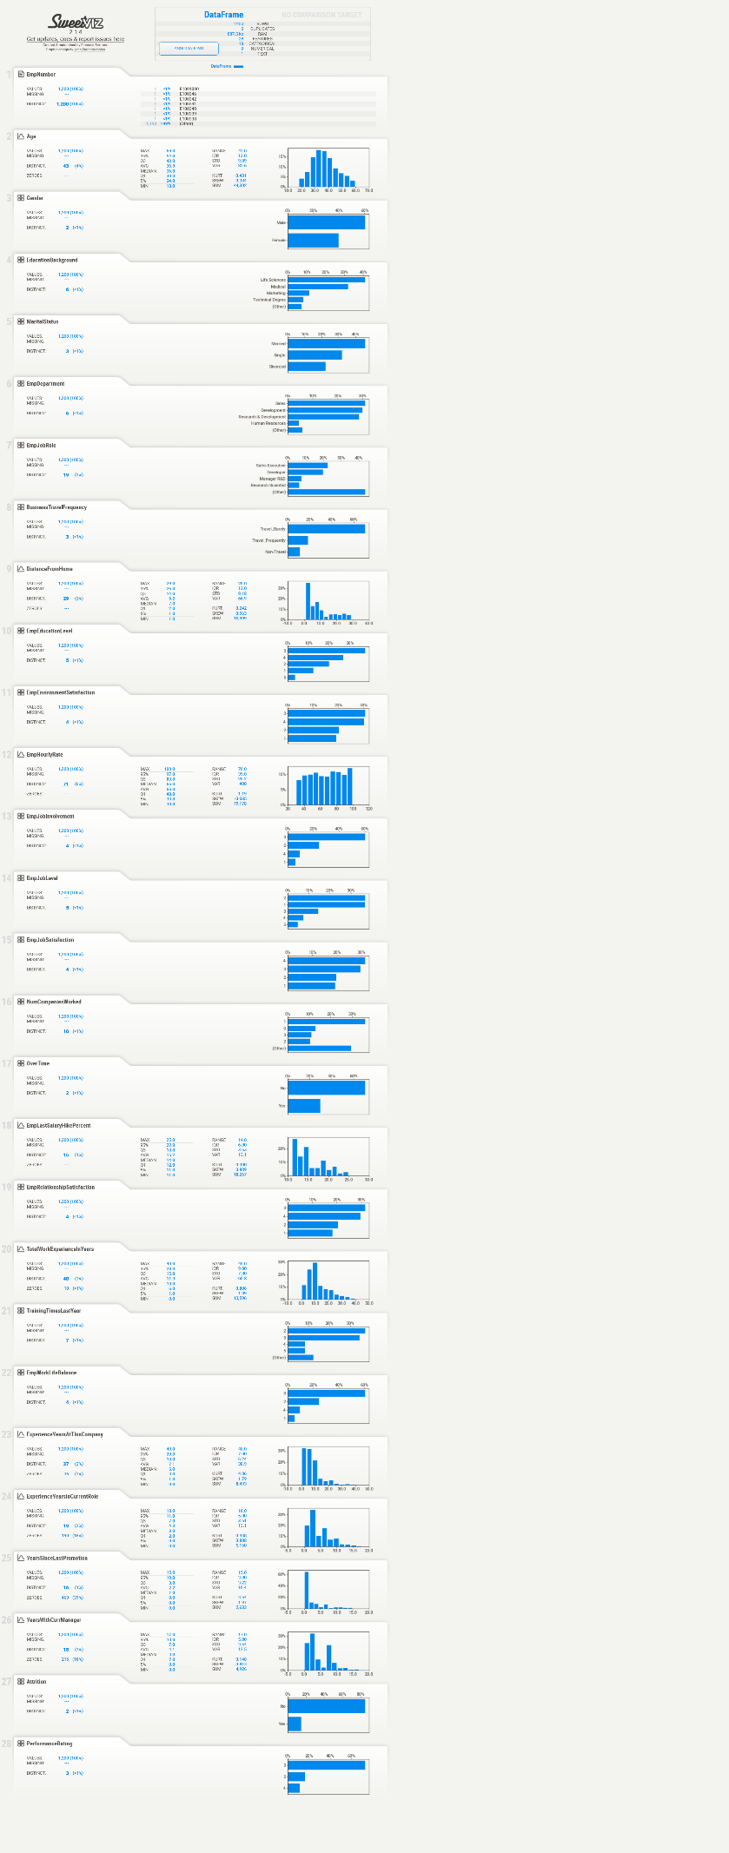

**Recommendations**:

Establish measurable goals and milestones to track progress.

Clearly define performance expectations and objectives for the employee.

Collaborate with the employee to develop a personalized action plan for development.

When discussing performance improvement with an employee, it's crucial to maintain a respectful and constructive dialogue. Focus on providing support, guidance, and opportunities for growth to help the employee reach their full potential. Because

EmployeeTravel : The workers who travel alot are more likely to quit then other employees.

Department : The worker in Research & manager are more likely to stay then the workers on other departement.

EducationField : The workers with Human Resources and Technical Degree are more likely to quit then employees from other fields of educations.

Gender : The Male are more likely to quit.

JobRole : The workers in Developer, Human Resources, Senior Develo are more likely to quit the workers in other positions.

MaritalStatus : The workers who have Single marital status are more likely to quit the Married, and Divorced.

OverTime :Over time rate is almost equal